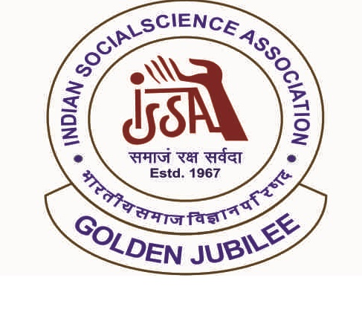

[***https://www.issaagra.in/index.php***](https://www.issaagra.in/index.php)

[***https://www.issaagra.in/young-social-scientist-award- contest1.php***](https://www.issaagra.in/young-social-scientist-award-%20contest1.php)

[***https://www.issaagra.in/reg-form.php***](https://www.issaagra.in/reg-form.php)

***ANNOUNCES***

***Young Social Scientist***

***Award Contest - (YSSAC)***

***@ Webinar: Dynamics of NEP: Rethinking Future of Social Sciences & Research - December 09 – 10, 2023***

* ***LAST DATE FOR SUBMISSION OF ABSTRACT + REGISTRATIONFEE***
* ***OCTOBER 20, 2023***
* ***LAST DATE FOR SUBMISSION OF FINAL MANUSCRIPT***
* ***NOVEMBER 20, 2023***

BROCHURE

HYPERLINK

DOWNLOAD

REGISTRATION FORM

HYPERLINK