https://www.issaagra.in/index.php
https://www.issaagra.in/young-social-scientist-award-contest1.php
https://www.issaagra.in/reg-form.php

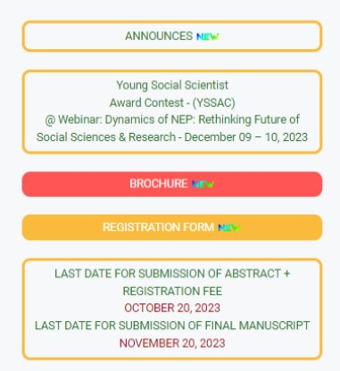

REGISTER FOR WEBINAR & CONTEST
https://www.issaagra.in/young-social-scientist-award-contest1.php
https://www.issaagra.in/reg-form.php

