**SYMBOLIC SACRIFICE**

**: Discourses on Navratri Festival in the City of Bhopal**

**Abstract**

*Hubert and Mauss (1964) rightly pointed out that the sacrifice was the basic rite performed in the ancient prehistoric religions and the theory of sacrifice is as old as religion. However, the nature and social function of the practice of sacrifice keeps on changing from time to time. This makes worthy for us to look into the ritual of sacrifice performed in recent years. The contextualization debate points out towards the necessity of analyzing the process of change in history where shift in anthropology has taken place. Culture and its rituals are now not viewed as internally static, consistent, homogeneous whole, but emphasis is given on culture as a dynamic institution with heterogeneous meanings and interpretations constructed and represented in the social praxis. In this study, in the light of this context, I have tried to look into the ritual of sacrifice practiced in the city of Bhopal during Navratri festival and the analysis of change that has occurred in the very ritual in Ibrahimpura along with the fusion of rituals with the gasp of wonder.*

**Keywords**

Sacrifice, religion, victim, intermediary, culture, ritual, wonder, change, dynamics, Goddess Durga.

**Methodology**

My motivation for writing this paper primarily came from my initial visits to *pandals* and *jhankis* with my family during my childhood when my father introduced the hopping culture to me. Sacrifice was something about which I and my sisters were not allowed to ask anything about. The human tendency tempts to venture into such discourse which is kept covert behind the bushes, thus giving rise to more and more curiosity and inquisitiveness.

This paper is based on ethnography and is culmination of the observations made during the Navratri celebrations in several Navratri pandals or *jhankis* as it is called in local language, throughout the city of Bhopal and specifically in Ibrahimpura from 2018 to 2021, which also helped in analyzing the attitudes, opinions, behaviors and other desired variables in a natural set- up. In terms of methodological approach, this work is an “anthropologically grounded study of a ritual” to understand the complexities and intricacies involved in the Navratri festival, precisely the ritual of sacrifice, and the nature of Goddess Durga or ‘Durga Mata’ as she is called. The text presented in this work is the performance of the culture gathered from the interaction with the individual and group respondents.

The overall silhouette of Bhopal in terms of its composition is very diverse and mixed because of being located in the Central India. Resourcefulness and resultant experimentation allowed varied imaginations, cultures, and practices to become a part of it, although retaining the backdrop of agricultural land. The focal points of this study are:

* Individuals and Groups:

I interacted with Pandit Sitaram Dwivedi, Pandit Shashank Parashar, Raghupati Ahirwar, Vandana Shastri, Mehtaab Singh, Savita Malviya, Santosh Maurya, etc. individually as well as a group involved collectively in the puja along with the outside visitors. Ritual practitioners include priests/ pundits, puja organizers, devotees, pandal hoppers, ritualists, narrators, eyewitnesses, and storytellers. These are not merely the subjects, but the subjects with actions, characteristics, and orientations in their entirety and comprise the primary sources for this research. Therefore the respondents in the text are referred to as devotees as they engage in knowledge production as well as dissemination relating to the puja.

* Social Events:

The festival of Navratri is although a pre- planned occasional[1] event (performance of specific rituals), but many of the activities performed in the pandals are unplanned and proceeds with the thrust, thereby resulting in ritual dynamicity. I have approached this festival as a social event and the specific rituals associated with this event as text.

**History of Sacrifice**

According to Marcel Mauss, sacrifice was originally a gift given by the primordial men to the supernatural forces in order to gratify, please and feed them. The meal played a very important role where the devotees assimilated the totem in themselves by consuming it and therefore become associated and connected with each other, which is true even today to some extent. Slowly with the pace of time, people started substituting the ancient totem with the domestic animals and cattle, but only in unusual and unfavorable circumstances. It appeared as the gift of man (owner of the herd) to God and in this way originated the act of gift sacrifice (1964: 2- 3).

Frazer (1935) identified an important function that remains associated with the process of animal sacrifice, i.e. carrying away with itself, all the evils and sins- disease, sickness, death, etc. Driving out of evil spirits remained an objective and important component in the process of sacrifice.These sacrifices were necessarily accompanied by the following significant events:

1. Appeasement and reconciliation with God
2. A sacrificial meal
3. Sprinkling of blood.

**Introduction**

One cannot actually outline a comprehensive, abstract scheme to fit in all the cases of sacrifice offered and here again contextualization and location becomes important. In Ibrahimpura, Bhopal, the sacrifice performed is objective rather than subjective in nature where the object of sacrifice receives the sacrificial action directly with an aim of social well- being and happiness. It is also occasional in nature and occurs once in a year. Mauss and Hubert defines sacrifice as *“…the religious act which, through the consecration of a victim, modifies the condition of a moral person who accomplishes it or that of certain objects with which he is concerned” (1964: 13).*

Out of four forms, *Olah, Hattat, Shelamim,* and *Minha* identified by Levicitus (as cited in Mauss and Hubert 1964: 16), the sacrifice performed here can said to be the *Shelamim* as the objective is to simply offer the divinity for thanksgiving, for completion of vows and for the well- being of all devotees and participants. A member from the group is chosen as a representative of the collectivity to perform the functions in the sacrificial ritual in pandals.

There lies an important distinction between ‘Durga Puja’ and ‘Navratri’. The term Durga Puja is typical and indigenous to the festival celebrated in West Bengal where Goddess Durga and her manifestations are worshipped from *Panchami* (fifth day) to *Navami* (ninth day). Whereas in case of Navratri celebrated in other parts of the country, especially Northern States of M.P. and U.P., the Goddess is worshipped for nine days and her idol is placed in pandals from the very first day. Navratri, a very renowned festival, celebrated in the *Asvina* month, on the first nine nights of the *Amavasya*[2], is dedicated to the worship of the Great Goddess Durga and her powerful manifestations. However, in case of Bhopal, this auspicious festival of strength and victory of good over evil is celebrated for eleven days. It commences on the first day and goes on till the next of *Dasami*, i.e. *Ekadashi*, the eleventh day of the nine- night festival. The immersion of the idol of Goddess takes place on eleventh day only after *Dussehra* (tenth day).

The Durga Puja practices a fusion of Vedic, Puranic, and Tantric elements of worship where consumption of non- veg is not a taboo. However, the Navratri is essentially a Vedic puja with very strict rules related to observances and fasts *(vrata)* to be kept for nine continuous days with no scope of consuming non- veg or even food grains by those who keep fasts. Both Durga and Kali Puja are performed during Navratri in Bhopal, unlike Bengal.

Public celebrations in pandals involve a number of community activities like *jagratas*, religious plays, devotional singing, dance performances, etc. As a result, people in large numbers hop around the city from one pandal to another. This overwhelming crowd, which Rodrigues call as “Pilgrimage Circuits” (2003: 295) move together for *Darsana* and gives a major boost to the small vendor stalls and local commercial shops.

**Ritual**

The word ‘ritual’ is derived from the term *“ṛta”*, which means ‘order’ and from the Indo- European root *“srew”*, which means ‘to flow’ (cf. Turner and Turner 1978: 243- 44). The first derivation points out towards the cosmological order in the society, whereas second derivation is indicative of dynamicity involved in the order (Michaels 2016). In the words of Nicholas Dirks, "Ritual now appears not only as a powerful way to produce the reality effect of the natural, but also as a way to contest and even appropriate that reality itself" (1994: 501- 502).

Navratri as an event is constituted by numerous micro events (Sacrifice, Kanya Pujan, Havana, etc.) and big events (*Astami, Navami, Dasami,* etc.). We will be specifically looking into the ritual of sacrifice performed on the day of *Navami*, thus locating micro in macro. Through participatory approach, I have tried to capture the simultaneity of the events inside the pandal with great precision.

**Wonder**

The German etymology of “wonder” is traced from the word *“wunder”,* which indicates a fracture or a wound and significantly the response to this wound (Srinivas 2018: 11). By going with the literal definition of wonder, it is described as “the emotion excited by the perception of something novel and unexpected,” which can extend to “astonishment mingled with perplexity or bewildered curiosity” (Oxford English Dictionary). The extraordinariness, unexpectedness, and apparently divine- like rupture of the mundane adds on to the characteristics of wonder (Vasalou 2015). Tulasi Srinivas takes account of “a sudden gasp of surprise” and “childlike amazement” while talking about anthropology of wonder (2018: 6). Philip Fisher defines wonder as “a sudden experience of an extraordinary object that produces delight” (1998: 55).

The important characteristics of wonder which we can recollect from the above definitions are: *it is extraordinary, unexpected, and surprising with a sense of childish curiosity[3] seemingly aiming to rupture the daily life mundane things.* Taking forward this working definition of wonder can help in opening new possibilities, prospects, and realities in this field of anthropology of wonder. Daston and Park extend the concept to the depth and claim that, *“beneath tasteful and respectable exteriors, we still crave wonders. . .We wait for the rare and extraordinary to surprise our souls” (2001: 368).* We will try to look into how the ritual of sacrifice transformed into symbolic sacrifice and how symbolic sacrifice and anthropology of wonder are related to each other.

**Nature of the Goddess, Puja and Rituals**

The puja can have different meanings for different devotees and it depends upon one’s own personal experiences with this festivity and worship. However, the rituals by their very nature remain enigmatic and unrevealing, the one which cannot be completely understood. This is apparently because *“religion addresses the fundamental mysteries of existence” (Rodrigues 2003: 309).*

Interestingly, Goddess Durga encompasses all sorts of beings, possessing different moralities, natures, and qualities *(satoguna, rajoguna, tamoguna).* She aims at transcending all forms of dualities: sacred- profane; rich- poor; husband- wife; man- woman; mother- whore. It also represents three aspects of *Sakti: iccha* (desire), *Jnana* (knowledge), and *Kriya* (action) and the Trinity of Gods and Goddess: Creator; Preserver; Destroyer: Brahma; Vishnu; Mahesh: Saraswati; Lakshmi; Kali. The term ‘Durga’ typically means unconquerable fortification. Her another prominent name *“Aparajita”* also denotes the same meaning: one who cannot be conquered or defeated. She is regarded as “the Cosmic Mother, creatrix, nourisher, and nurturer of the world, or as the regal warrior-goddess Durga, whose many arms wield a host of weapons” (Rodrigues 2003: 17).

The festival of Navratri is very vibrant, rigid, and flexible at the same time. It necessarily proceeds in a linear way (from *Ekam* to *Ekadashi*) but also goes back and forth in terms of rituals. Fascinatingly, it also remains enmeshed in past, present, and future at the same time dealing with all of them together, for example as in case of sacrifice performed on *Navami.* There is nothing as banal or trivial in the everydayness of the rituals performed during the Puja for eleven days and each of the processes are highly significant that they cannot be skipped, however can be altered a bit depending upon the situation.

**Sensory Participation**

**(a) Smell**

The Air element is captured with the fragrance of sandalwood paste, incense sticks, fresh flowers, lit camphor, and sweet odor of food. The pleasant odor of *dhuni* and *guggul* is unforgettable for the devotees.

**(b) Hearing**

The pure sound of the mantras, *bhajans* sung by women, *jagrans* conducted by the local singers, and devotional songs played in the pandals, all contributed in enhancing the hearing experience of devotees. The sounds of *ghanta, dhol,* and clapping during *aarti* also act as a pull factor for devotees.

**(c) Vision**

*Darsana* is relatively an intimate encounter with the Goddess in which a devotee shares many of the personal feelings, joys, sorrows, emotions, memories, and past experiences. It’s like having conversation with the Mother without even uttering a word and sharing your inner psychological self with her.

**(d) Touch**

People go crazy during the festival and visit for pandal hopping, touching with each other in the crowd.

**(e) Taste**

Worshippers and deities taste the same food, it is first presented to the Goddess as *‘bhog’* and then eaten by all the devotees present in the form of *‘prasada.’*

All the five sense are interconnected to each other in significant ways and the experience of one sense may not be complete or fulfilling for an individual without the assistance of others. The spirit of the festival and associated wonder is not limited within the confines of the pandals or *jhankis*, but stretched throughout the city: physically, visually, verbally, aurally, and aesthetically.

**Exclusionary Aspects of the Ritual**

Goddess Durga is the symbol of strength who marks the victory of good over evil; she has slayed the demons like *Mahisa, Chanda, Munda, Raktabeej,* etc., but at the same time she is mysterious (Maya), *Aparajita* (one who cannot be defeated), and impenetrable *(Durgam)* and therefore a reason of wonder for people. The puja of her identity can have many different, though significant interpretations. This imagery of Goddess Durga and Mahisasur[4] parallels in the social arena when the sacrificer assumes the role of goddess and slays pumpkin treating it as a demon. This marks the reenactment of the battle goddess Durga fought with demons at different points of time. Durkheimian interpretation (1965 [1915]) that says the deity represents the society itself in collective effervescence can be applied here. However, this analysis does not take into account the variations or changes involved in the process of religious symbolic constructions.

The prominent contradiction that lies here is that the goddess who actually slayed the demons is female, then how come is this ritual being performed predominantly by males, is a larger question to pose. Even the presence of women in the pandal during this ritual is at the very least not welcomed. The festival that marks the celebration of female power is predominantly handled by males. The identities (like gender, caste or class) remain embedded in the larger structure and in the local contexts, but the representation of these identities (Hooks, 1999) is minimal as the presence of women and outcast people is similar to the absent presence. Therefore, making sense of the identities and extending it to their experiences has become extremely important. There lies a great possibility to study gender and caste dimensions from below in Navratri. But this is something out of the scope of this paper and will be dealt further separately.

**Consecration of Sacrifier and Victim**

The idea of ‘consecration’ remains associated with the process of sacrifice. It extends both to the object to be sacrificed and the moral person who bears the expenditure occurred during the ceremony. The ‘sacrifier’ is the person or the subject who is entitled to receive the benefits or ill- effects of the sacrifice performed, *“We give the name sacrifier to the subject to whom the benefits of sacrifice thus accrue, or who undergoes its effects” (Mauss and Hubert 1964: 10).* The victim and the devotee undergo the transformation for acquiring a religious character and the moments of wonder arise here when the conditions of sacrifier and victim are altered and they are made to rise to the level of divinity, to the state of elegance and charm. The aura associated with the person who keeps fast and performs sacrifice, and concomitantly negotiates his status with others invites wonder. Sherry Ortner (1978) in case of Sherpas of Nepal rightly demonstrates that rituals act as a medium to negotiate statuses, interrogate prevailing power relations in society, and paves the path for developing new social structures.

Wonder is fluid in nature and can occur together with beliefs. Devotees believe that if the compliances before the sacrifice are not observed properly, it might result into misfortune. Priest in one of the pandal of Ibrahampura narrated a story about his own experience of non- compliance:

*Santosh, who was supposed to make a sacrifice on Navami, drank heavily one night before. He was stinking badly when he came for the ritual. Just few hours after making sacrifice, he met with a huge accident, thus an indication from Mata that she hasn’t accepted the sacrifice. Surprisingly, he was not badly injured, only blood came out from his knees and elbows: goddess has satisfied her need.*

Regarding this incident, the convincing interpretation for devotees as well as priests was the failure of Santosh to perform a proper sacrifice and fulfill goddess’s need of profane and resultant flow of blood from his own body, indicating that goddess has herself taken sacrifice from Santosh and satisfied herself. Such instances of wonder are capable of getting carried forward generation to generation and surviving almost infinite years. We can comprehend that the moments of wonder[5] here are fused with beliefs and the resultant fear.

**Atmosphere of Sacrifice**

Sacrifice is a sacred religious act that essentially requires a religious atmosphere and religious agents to perform the act. To introduce the sacrifier[6] in the sacred world is equally important and for this purpose he[7] is made to perform certain rites and observe compliances:

* The sacrifier is shaved and his nails are cut.
* He is made to take a purification bath and wear new clothes or at least washed ones, thereby indicating the beginning of new existence for him.
* He is dressed in traditional *kurta- pyjama* or *dhoti* which cannot be black in color[8].
* His head is covered with white handkerchief. He is made to compress his fists and told to walk around the fireplace[9].
* He must not be touched by others and must abstain from indulging in sexual relationship and is strictly prohibited from consuming alcohol.

After performing these rites and observing the prescribed compliances, the sacrifier is deemed to be fit for the ritual of sacrifice and the actual ceremonies begin. Interestingly, sacrifice is a sacred religious act that calls for profane. Wonder doesn’t discriminate between sacred and profane and accepts both with the same excitement.

**Goddess Kali: One who is Fond of Blood?**

Myths are the illogical ways of organizing the things in such a way that the listeners feel the structural unity and relevance of it by making connections. Myths may not necessarily be in the linear pattern of a written document, nevertheless engages in reading the meanings in criss- cross way (Strauss, 1978). One should also keep in mind that listening to a myth is different from reading a myth in terms of meaning- making. A local mythology reveals the nature of the goddess Kali who is a sacred furious character, but profane at the same time because of her fondness for drinking blood. Urmila Devi, a grandmotherly figure for me, narrates:

*Once there was a loyal priest of the Kali Temple who was very regular and punctual. He was serving that temple from past many years and was very experienced in performing rituals and offering bhog. One day his wife fell severely ill and was not recovering because of which he was much tensed. He rushed to the temple to perform daily puja which was his mandatory job. He also took his only small son with him as there was no one at home to take his care other than her ill wife. In a hurry to go back home, the priest forgot to offer bhog to goddess Kali. Mistakenly, he also forgot about his son and locked him up inside the temple. After few hours when he realized the blunder he has done, he went back to the temple, but couldn’t find his son. The only thing he found was a small piece of his son’s shirt coming out of the mouth of goddess Kali. The priest became insane after this incident.*

It follows from the story that the goddess thought the priest’s son is her *bhog* for tonight as there was no other *bhog* offered by the priest that night. It highlights the mistake of the priest who forgot to offer the goddess because of his personal life problems. Because such thing did not happen before, the innocent goddess ate his son considering him as *bhog.* The nature of the goddess Kali is known to all, she is a warrior, slayer of demons, and fond of blood and flesh, at the same time, she is innocent who helps her devotees all the time and is just one call away, therefore as Rukmani Bai reiterates, we human beings need to adjust according to her requirements and fulfill it. Committing any sort of mistake in her service is simply unacceptable. Forgetting goddess while engaging in worldly affairs or forgetting to serve her because of personal problems can have grave repercussions on individuals. Again, the wonder is fused with the component of fear and belief here. The blood comprises a central theme in many of the stories and myths narrated by the devotees and is cause of resultant wonder that doesn’t discriminate between sacred and profane.

**Role of Intermediary**

At the very beginning of the ceremony, the sacrifier drinks the sacred water *(Ganga Jal)* three times because rivers are considered as pure[10]. The role of an intermediary or a guide is of utmost importance because he prevents the sacrifier from committing any sort of errors that can prove fatal for him. In this particular case we are talking about, a ‘Pundit’ or ‘Priest’ predominantly remains the intermediary:

An intermediary, or at the very least a guide, is necessary…More familiar with the world of the gods, in which he is partly involved through a previous consecration, he can approach it more closely and with less fear than the layman, who is perhaps sullied by unknown blemishes (Mauss and Hubert 1964: 23).

Priest or Pundit possesses a certain kind of religious charisma that allows him to directly enter into the ritual processes without any sort of preliminary action. He appears and enters in the process like a divine being. The priest initially purifies himself in order to perform the sacred ritual and then becomes a mediator between the divine and mundane, the deity *(Devi)* and the votaries *(Yajamana)* in order to facilitate the ritual to be followed by the distribution of *‘prasada[11].’*

**Place and Instruments**

The ritual of sacrifice cannot take place randomly at anytime or anywhere. The place for the ceremony of sacrifice must be sacred in nature and should be near or in front of the holy place because immolation outside the sacred sphere is simply viewed as murder or brutality. This holy place or sacred sphere is consecrated before performing the ritual of sacrifice through a number of rites. The place undoubtedly remains Navratri pandal where rites and rituals are performed just in front of the idol of Goddess Durga. On the ninth day *(Navami)* of Navratri, *‘Hawan’* is performed followed by the sacrifice of white pumpkin. The sacrifice is performed compulsorily with a sword.

**Ceremonies before Sacrifice**

First of all, ‘*vedika*’, ‘*vedi*’ or *‘hawan- kund’* is built with bricks and cow dung inside *‘vihara[12]’*. Then the fire is set inside the *vedika* in order to invoke *‘Agni- dev’*: the God of fire who is considered as the indicator and proof of purification. The fire is also believed to destroy the evil spirits and demons. The religious character of *vedika* is more prominent than *vihara* because of the very reason that Agni is invoked inside it.

After raising the fire inside *vedika*, *Hawan* is performed and all the Gods and Goddesses are invited through mantras recited by the Pundit. During *Hawan,* the *bhog* made is served to the gods and goddesses along with *hawan- samagri.* The whole process of *Hawan* which is to be followed by the sacrifice must go on till the end in ritual order without any sort of disturbance or interruption. One must note here that the ritual of sacrifice demands a credo *(shraddha)* on the part of sacrifier.

**The Victim**

There are certain attributes of the victim- it should be of definite color, age, and sex. Initially in 1960’s when the festival of Navratri marked its beginning years in the city of Bhopal, a black male goat *(bakra)* was sacrificed on the ninth day *(Navami)* of Navratri. It was not an easy task and to refrain from any sort of curse or vengeance on the part of dead animal, the God of Animals was worshipped and invoked in order to seek the permission for performing the sacrifice and was convinced in the name of welfarement of all. This is how the ritual of sacrifice was originally performed:

All the important components of sacrifice are now present inside the pandal and the final supreme act of sacrifice is known as *‘Bali’* in local language is to be done. The neck of the victim is cut down with the help of a sword in one stroke. With this act, the blood of the victim starts flowing and is allowed to flow away without any hindrance as it is the share of spirits. Then the blood further shed after the slaughter is offered to Goddess *Durga* or Goddess *Kali*, which ever might be the case (Rodrigues and Sumaiya 2010: 1).

The blood of the victim is considered to be precious in nature and its remains are treated with religious respect. The blood is typically offered to the Goddesses in order to make them happy. *Agni- dev* is entrusted with the job to hand- over the offerings to the Gods and Goddesses. Offerings not only include blood, but a number of other food like *sabji, puri, halwa, chana, raita, kheer,* etc.Such offering is known as *‘Bhog’* which is then mixed in the larger utensils which contain the food so as to distribute amongst the devotees. Milk is an important component without which a libation called *‘Charnamrit’* cannot be made. All Hindu potions that are offered to Gods and Goddesses are made after mixing milk or milk products as milk is the signifier of the essence of sacred animal cow. Its liquid essence and fertility is presumed to be auspicious and fulfilling.

Sacrifice and *Bhog* is necessarily followed by *‘Bhandara’* which literally means a ritual feast offered to each and every person irrespective of caste, class, gender, race or ethnicity who visits the pandal on the day of *Navami* at the time of feast and this consumption of the *bhog* or *prasada* signifies the convergence of the human realm with the divine realm.

**Exit or Returning**

Remains of the victim are destroyed completely by fire and utensils are washed. From here onwards, the process of returning to the normal life starts. The sacrifier enters into a sacred religious sphere through preliminary initiation, achieves a terminating point, and then enters again into the realm of profane.

Exit in order to return to the normal life is extremely important, *“All those who have shared in the sacrifice have acquired a sacred character that isolates them from the world of the profane. Yet they must be able to return to it. They must step outside the magic circle in which they remain enclosed” (Mauss and Hubert 1964: 45- 46).* After exiting from the sacred domain, the sacrifier is free to drink liquor and indulge in sexual activities.

**Analysis of Change and Politics of Distinction**

After a decade or so, the ritual practice of sacrificing a black male goat in order to make the Goddess happy got substituted with another non- violent ritual which is practiced till date. Earlier a dark (black) colored male goat used to be a sacrificial animal, but now a surrogate offering of white pumpkin *(safed kumda)* is made.According to Pandit Parashar:

*“killing an innocent animal is not preferred by devotees, but the continuation of age- old tradition is also important, so the middle way round is to offer a symbolic animal to the goddess…”*

A number of acts were introduced to protect the animals, for example Prevention of Cruelty to Animals Act, 1960 was implemented in the following years with stringent measures. Although slaughter of goats is not under the act, people became more and more conscious about being vegetarian and acts of cruelty against animals. As a result, the sacrificial ritual witnessed a shift in its original version. In place of sacrificing a black male goat, devotees eventually started sacrificing a white pumpkin *(safed kumda).* It is made to look like a goat by inserting four wooden sticks as legs. After cutting the white pumpkin with a sword, vermilion is sprinkled on both the sides so as to make it look like a goat.

The original tradition is substituted with such an arrangement in which tradition is combined with the dynamics of the contemporary times. Now if in any pandal, the actual sacrifice is performed, it marks as a moment of wonder and shock for devotees. However, implementation of acts was not the only reason for such a shift in the ritual of sacrifice practiced here. Another important reason for this change was the tendency on the part of Hindus to distinguish themselves from Muslims who are viewed here as precursors of animal cruelty and violence. In the parts of Old Bhopal dominated by the Muslim population, the festival of Navratri means freedom of nine days for Hindus to occupy the roads and intersections for constructing the pandals and play loud music and *bhajans* on speakers during *aartis* and *jagrans*. The Hindus living in the Muslim dominated areas survive through the spirit of festival throughout the year.

According to devotees, they completely refrain from making sacrifice of an animal because it’s not morally correct, it’s unhuman, and it is done mainly by Muslims, *“what will then be the difference between them and us?”* This politics of distinction allows for the continuation of exclusive identity even in the age of neoliberal fluidities.

For me as a researcher, it was a moment of wonder to know that there are very less instances of religious disharmony or communal violence here. The adherence to the principle of religious tolerance can possibly be one explanation as both the religions are surviving here symbiotically from past many years, but still there is an urge on their part to distinguish themselves from each other. Wonder as a discourse (in the form of narratives, legends, myths, stories) and as a practice (in everyday lives of people) works through these “creative rituals” (Srinivas 2018: 15).

*Ritual creativity and distinctiveness* give the space for strategic improvisation and innovative variation through the experimentation allowed by the contemporary circumstances. This is very similar to what DeNapoli (2017) terms as “Experimental Hinduism” where Hindu rituals interact with the forces of modernity, cotemporary circumstances, and give rise to ingenious improvisations. Hindu devotees in Ibrahampura weave the social, political, cultural, and economic gossamers (threads) of their lives with the creative ritual. What it means to be a Hindu and specifically Indian Hindu is showcased by devotees here with the demonstration of core values of Hinduism and its relevance in dealing with the uncertainties of contemporary life, however, these values are subject to negotiation and change (DeNapoli and Srinivas, 2016). Anthropology of Hinduism is incomplete without rituals and resultant wonder.

**My Own Positionalities**

The priests in the pandals of Ibrahampura and the devotees there who organized the puja and performed the rituals helped me venture into the ritual distinctiveness and anthropology of wonder. My own positionalities taught me major lessons:

I remember how I was being ignored at the pandals as I wore jeans and shirt during my initial visits. Looking at my disappointment, my sister suggested me to change the way I dressed. From there on, I started wearing traditional wear. People seemed interested in talking to me and giving me responses. I realized, the connection that people draw with you is very important. They should get a feel that you are part of them or not very different from them. Some commonality and similar life chances gained after spending time with them in the specific moments of ritual adds on to this research.

A sudden thought entered my mind and made me feel that I am changing myself to suit the field, is it not the encroachment of my choices, my likes and dislikes and ultimately myself? Only very later I realized that I have actually started liking the way I dressed that circumstances led me to and this is how we humans habituate with something. My gender, dressing style, and language *(Bundelkhandi)* gradually started imprinting their effects on my ethnographic research. I couldn’t even remember, when my strategy to survive in pandals and interact with people became a method of collecting data:

*Ethnographic subjectivity is an evolving state that emerges in participant observation (Chawla 2006).*

I was aware about my identity as a male researcher but that doesn’t stop me from doing feminist ethnography or doing research from masculine viewpoint. Judith Stacey and Kimberly Huisman (2008) have reminded me time and again the complexities involved in the field and how to deal with them with a blend of reflexivity, reciprocity and positionality. Also the reading of literature might help one in understanding how to approach the field, but the real challenges are met out only when one enters the field.

I started sharing similar life chances with my respondents and this point of confluence proved a benchmark for my research as it gave me in- depth insights of the rituals happening and what devotees feel and think about it and most importantly, how they experience it. There were many hierarchies present which people didn’t like, especially women, and the norm that females ideally should not be present at the time when sacrifice is made. Multiple subjectivities and roles allowed them to perform many things but also restricted many. The most remarkable thing I learned from them is the ‘politics of resistance’ and that too in the face of inbuilt, subtle patriarchy. They were not allowed to come out of their houses or wander freely because of the Muslim majority in the area, but Navratri was the time they could come out of their houses decked in beautiful, gorgeous *sarees* and enjoy the rituals till late night.

The transformation of my ‘self’ grew as not a mere capitulation or compromise, but a method, a strategy to upturn or at least resist, thus again giving rise to moments of wonder. I realized that what appears to be as a privilege from outside can possibly be accompanied by precariousness within.

**Fracturedness of Ritual**

The loud processions, beats of *dhol* (drum), grand *pratimas* (clay image complex), and most importantly, the ritual of sacrifice, all serve as examples of great wonder and fascination on the part of devotees, practitioners, and priests. *These instances of wonder make one think whether the desired state of being is solidity or rupture? Whether in contemporary times, the motive behind the performance of ritual is to return to the normalcy or to engage in the pursuit of wonder?*

The screams, chats, and excited noises of devotees heard during the ritual of symbolic sacrifice made me convince that the moment of rupture*,* the occasion of momentary fracture that occurs during the performance of ritual is of utmost significance in which the practitioners encroach their own ritual space and want to linger for more time.

The moment that wonder invites is a magical and transformative moment in itself as it offers the rupture of ordinary and allows practitioners to do certain extraordinary things. The aura connected with observance of ritual in itself is self- fulfilling for practitioners. The transformation of self within the purview of ritual also indicates the momentary nature of fracturedness in a ritual (s).

**Capture- Rupture Dichotomy**

How ritual is interacting and engaging with the neoliberal modernity and politics of distinction, at the same time retaining tradition and giving rise to the anthropology of wonder in Bhopal is interesting. The experiences of wonder are felt by priests, practitioners, devotees as well as by laypersons who do not follow or observe any ritual. The ritual of symbolic sacrifice resist and appropriate the spirit of modern capitalism at the same time. Using creative, distinctive, and *idiosyncratic rituals* provides the practitioners with the agency of their own to embark their own space and express themselves in terms of emotions and expressions, thus moving from the texts to discourses.

Ritual creativity for Tulasi Srinivas essentially means the changes in ritual which come under the purview of *“transformative moment of wonder” (2018: 6).* This transformative moment appears as magical and sometimes impractical to the practitioners, nevertheless they perform it with great fervor and enthusiasm because the ritual creativity and distinctiveness shifts the religious identity from the doctrines of orthodox to the treatise of praxis. The ritual processes can be exquisitely understood and studied within the framework of anthropology of wonder which treats ritual as alive, creative, and open to improvisations.

Ritual processes are not very consistent and rigid in a way that they are characterized by numerous small shifts at minutest micro levels. The dialectics of ritual focuses not only on capturing the elements of ritual and neoliberal life in the due process, but also rupture many at the same time. This is how the new version of ritual process comes into being after entering into dialogues, conversing, and building upon the miniscule ritual shifts. The dialectics between rupture and capture give space for creativity in the moment of fracture (Bateson 1936) offered by the ritual in the precarious everydayness of life in Bhopal.

The whole process of sacrifice itself can be viewed as a moment of rupture, a moment of wonder. *It represents fracture or rupture in the sanitized space of other Navratri rituals, for instance, Kanya Pujan or Ghat Sthapana. What is the purpose of this claimed to be sacred ritual?* Not necessarily restoring normalcy as it was earlier. Lingering in the very moment or ritual on the part of devotees is very much possible. Performance of the ritual requires devotees to get high and enter into a different state of mind and body altogether. Devotees wish to continue the amazement with the presence of devil/ evil, however it will be destroyed by the symbol of goodness, Durga Mata in a moment.

The moments of capture during *hawana* are followed by the moments of rupture during sacrifice, the bhog offered to the goddess is to satisfy her needs of sacred and the sacrifice offered is to fulfill her desires for profane, which ultimately results in the restoration of normalcy. But the moment of rupture enables people to experience the evil which is a rare instance in all sacred rituals of Navratri. Even sacrifice is considered as sacred but it allows to have a glimpse of profane. Devotees wish to linger in the moments of rupture during sacrifice because of the same reason and perhaps my venture into this research arises from the similar curiosity to know the unknown or deliberately kept hidden process.

It has been well explored by the anthropologists that rituals as a structure emerge from the ordinary world and ultimately return to it (Biardeau, 1976), but it is to be noted here that in the moment of extraordinariness, in the moment of wonder, ritual allows its practitioners to get into other time and space and manifest diverse temporalities. Levi-Strauss (1966) marked that even when the outcome a specific ritual is known to its practitioners, it nevertheless allowed the refraction of their world.

Victor Turner (1969 a, b) posits that the liminal, momentary space provided by ritual is “anti- structure” characterized by some sort of boundedness and ephemerality. Momentary anti- structure created by ritual helps in maintaining the solidity and stability of structure, but the stability of structure is overvalued, often at the cost of dynamics and creativity of rituals.

What we are trying to do here is exploring ritual not only in terms of its functionality and efficacy or what it sets out to achieve, but also the dynamic reorientation of ritual in terms of imagination when it intersects with politics of distinction. Social structure is something static in nature whereas cultural change by its very nature is dynamic in its pursuits, therefore at odds with each other. Geertz (1957) by drawing from the case of funeral of a Javanese boy concurs that, ritual can be viewed as a site of dynamicity that makes possible the birth of a new cultural order.

**A Way for New Possibilities**

The devotees and religious practitioners inside the pandal were very cheerful filled with great joy and excitement to conduct the rituals with a hope of better future with new possibilities, thus ignoring the precariousness associated with their contemporary lives. Their efforts to maintain the tradition, although with some sort of modifications occurring year by year, within the modernity could be grasped when they tried to live their present to the fullest, joked, and giggled together, revered and respected the deities in the clay image complex with the hope of a better prosperous future.

Studying the experimental and dynamic regime of ritual within the arena of the anthropology of wonder provides us with the new ways of discerning, interpreting and recording the reality which are necessarily more social and less individualistic. This regime of ritual fused with the excitements of wonder enables people to view their future in terms of new radical hope and deal with the over- increasing clutch of alienation.

Celebrating and performing rituals in their own traditional way (although with some variations necessitated by the politics of distinction) allows them to have a homely feeling in the modern capitalist world. These rituals and celebrations are viewed by people as a measure to reduce the stifling effects of religious domination through the joyous reconstruction of something endurable in the current uncertain era. Western philosophy and texts have rarely encapsulated the concept of wonder in detail, but the point of great contention here is the fact that the instances of wonder have been grounded and nurtured by the people as they allow the communities to grow some social hope for a better future.

The point to be highlighted here is for many devotees, their whole year passes in waiting for the Navratri to come and doing preparations for its arrival. Devotees and local residents view their future as a ‘snapshot’, to use Sophie Day’s term (2007), where the images of the future celebrations of Navratri lead them to deal with or bracket the misery and discrimination they face in their current lives. Therefore they try to capture their future as a happy snapshot.

When the deity of Goddess arrives, it becomes part and parcel of human lives and people greet everytime they pass through the intersections where pandals are constructed: while going for job, shopping, exam, evening walk or any other work. Taking *‘aasheesh’* or *‘aashirvaad’* of the deity before leaving for any work is extremely significant and obvious. The desire of the devotees for aspirational mobility gets intertwined with their devotional life and rituals of the festival.

The aspect of everydayness in the life of devotees is unexplored and can be further researched. What goes in the aftermath of the event or afterology (Sahlins, 1999) has also not been sufficiently explored, however these were out of the scope of this research. Notably, this text is not intended to become a document, but rather a process of unfolding the events and rituals with which the researchers can engage further.

**Element of Contract in Ritual Creativity**

The stories my respondents shared with me were sensitive. How mother has been kind throughout and provided them good health and prosperity, taken care of family members, and helped during the times of need were all the moments of wonder for devotees.

Vandana Shastri shared how doctors refused for her normal delivery and the only option left was Caesarian, but her goddess and the vow before her made her normal delivery possible. Now it’s her turn to return back the requisites of *‘mannat’*, present *‘chadava’* in front of the goddess, and keep her promise. Most importantly, her husband is required to perform sacrifice (symbolic) before goddess and satisfy her need for profane. *Mannat* here acts as an agreement or contract with the goddess to be terminated with *chadava* on the fulfillment of desires.

Getting deep into this instance, one could think how a wonder is different from miracle? I believe the boundary line is very thin and the moments of wonder can very subtly transform into miracle. Once a wonder becomes miracle, it has a good potential to get transformed into superstition. I strongly feel that there is a need to formulate new concepts to observe and study events of change and the further dynamics involved (Barth 1967: 661).

**Conclusion**

Changes in the performance of ritual invites inevitable opposition and is considered as ‘a huge mistake’, however it’s imperative to treat the rigidity of processes as a “façade of structural consistency that hides the internal tensions and accommodations generated between doctrine and practice by the human foiblesand social ambiguities of everyday life” (Herzfeld 2015: 22).

Catherine Bell beautifully recapitulates, “Ritual as a performative medium for social change emphasizes human creativity and physicality: ritual does not mold people; people fashion rituals that mold their world” (1997, 73). Rituals can be and generally are very creative and ingenious in nature, “Appropriating or modifying rituals when convenient or desirable,” they suggest, is “the norm” (Penkower and Pintchman 2014: 17).

The crack or the fracture provides an empty space to the creation to manifest itself in creative form. Brokenness endures creativity and allows it to flourish. Applying this corollary to the ritual, it performs two important functions: repairing the broken and allowing creativity to flourish in the crack; domesticating dangers (communal violence) within it (Gennep [1909] 1960; Seligman et al. 2008; Evans-Pritchard 1956; Turner 1974; Gluckman 1977).

The sacrifice is not always optional in nature and is demanded by Gods and Goddesses for satisfying their need of profane. However, the submission and abstention done by the sacrifier is not without the selfish ends and there always remain an element of contract in the performance of the rituals. The analysis of the ritual of sacrifice reveals that pure and impure components, sacred and profane components are not exclusively opposites in nature, rather they are the two faces of the same religious reality. Through the ritual of sacrifice, profane is being made sacred through communication and involvement, and thus made to survive. The victim remains the signifier of good and evil, sin and virtue, death and life, illness and health at the same time.

The sacrifice is a social function because it remains associated with the social matters. With the symbolic sacrifice made to Gods and Goddesses, the character of community gets renewed yearly. The essential features of a social entity like strength, weakness, good, evil, health and illness are replenished periodically every year. In this way, the social function of sacrifice (both for individual as well as collectivity) gets fulfilled. Probably this is the importance of sacrifice for Society and for Sociology. But what if it today serves more to fulfill the desires of people to enter into another realm of existence, which in turn serves as an escape from daily life for them?

The practices of doing and undoing, capturing and rupturing, faith and loss, and joy and sorrow, forms the complex whole of wonder and excitement. Rituals being a part of everyday lives of people allow their entry into extraordinary state of affairs. The question that arises here is, when something unique in a ritual becomes normal and routinized, does it still fascinates people as a wonder? In this case, definitely yes as the ritual is occasional in nature, occurs once in a year, and remarkably it offers the momentary glimpse into profane. A nuanced micro analysis of the ritual of symbolic sacrifice which is definitely strategic and joyful in nature, reveals that it is filled with serendipity, despite being in the world of neoliberalism and uncertainty.

Anthropology of wonder deals not only with the wonder in a specific event or place, but also with the wonder of researchers when we encounter these events. As we have seen throughout the paper, the moments of wonder are fluid and can take the form of fear, miracle, shock or belief. Lastly, I am not claiming the completeness and closure of the text, rather I view this text as an invitation for further research, enquiry, and unfolding in the field of anthropology of wonder and ritual.

**Notes**

1. As it occurs once in every year.
2. Waxing new moon.
3. It is worthy to note here that the feeling of curiosity can be accompanied by confusion and bewilderment on certain specific occasions.
4. *Mahisa*, a buffalo demon was capable of taking any shape and could only be killed by a woman as a result of boon granted by Gods. *Mahisa* became fearless and heavily underestimated the power of a woman. In order to defeat him, Gods pooled their weapons and conferred their strengths upon a newly formed, beautiful and charming Goddess, named Durga with a lion *(Singha)* mount who beheaded *Mahisa* in a deadly combat.
5. Wonder should not be misunderstood with wondering or dreaming. It is the moment of fascination that erupts while venturing into the creative order of different kind. For researchers, fieldwork itself is a source of great wonder and excitement as it facilitates the delving into the unknown, “Indeed, to wonder is to engage in a cognitive as well as an emotional process” (Srinivas 2018: 223).
6. Sacrifier is treated as profane before the process of consecration and it is utmost important to change his condition or present state.
7. In ancient times as well as even today, only male members are allowed to perform the ritual of sacrifice and this might be the reason Mauss has used the single- gendered term, i.e. “he” to denote the sacrifier. I have used ‘he’ as a pronoun because of the same reason.
8. Black is the favorite color of Goddess Kali and it is believed that she gets angry when her devotees wear black color as she possesses the sole authority on that color. The most terrible manifestation of *devi* is ‘*Kali*’: "wearing the garland made of demons’ skulls, roaring and staring at the enemy, while her tongue sprawling out and eyes becoming reddish in anger… (Shri Durga Saptashati, ch. vii, lines 7-9, from Jagadisvarananda, 1953, p. 95). After attacking ‘*Raktabeej’* (demon who’s every drop of blood acted as a seed for his re- emergence in thousands of number), *Maa Kali* discovered that she could not let fall even his single drop of blood on earth. She then decided to collect his blood in tile and drink it off in order to prevent it from falling on the floor. In this way, she killed *Raktabeej* as well as his thousands of appearances. But in the wake of killing him, Kali became so furious and aggressive that it became very difficult for anyone in the entire universe to calm her down. At last, Lord Shiva, her husband interrupted and slept in her way. In an extreme anger, Kali kept her both legs on her husband. As soon as she realized that she has committed a sin, her tongue, which was dark red in color because of drinking blood, came out and she finally came in her normal form of ‘*Parvati*’.
9. Walking around the fireplace has connotation with the foetus that moves within the mother’s womb.
10. These rites are not peculiar to Hindus only. The sacrifices performed in Ancient Greece and Rome provided a number of such examples. For more, refer Hubert and Mauss (1964).
11. Blessed offerings made to the Goddess for her consumption and consumed by the votaries later.
12. A fairly large rectangular space where religious ceremonies are performed is known as *‘vihara’.*

    **References**

    Barth, Fredrik. 1967. ‘On the Study of Social Change’, *American Anthropologist,* 69 (6): 661- 69.

    Bateson, Gregory. 1936. *Naven: A Survey of the Problems Suggested by a Composite Picture of the Culture of a New Guinea Tribe Drawn from Three Points of View*. Stanford, CA: Stanford University Press.

    Bell, Catherine M. 1997. *Ritual: Perspectives and Dimensions*. New York: Oxford University Press.

    Biardeau, Madeleine. 1976. ‘Le sacrifice dans l’hindouisme’, in *Le sacrifice dans l’Inde ancienne, edited by Madeleine Biardeau and Charles Malamoud.* Paris: Presses Universitaires de France, pp. 139- 54.

    Chawla, Devika. 2006. ‘Subjectivity and the Native Ethnographer: Researcher Eligibility in an Ethnographic Study of Urban Indian Women in Hindu Arranged Marriages’, *International Journal of Qualitative Methods*, 5 (4): 13- 29.

    Daston, Lorraine and Katharine Park. 2001. *Wonders and the Order of Nature*, 1150–1750. Rev. ed. New York: Zone Books.

    Day, Sophie. 2007. ‘Threading Time in the Biographies of London Sex Workers’, in Janet Carsten (ed.): *Ghosts of Memory: Essays on Remembrance and Relatedness*. Oxford: Blackwell, pp. 172- 193.

    DeNapoli, Antoinette Elizabeth. 2017. ‘Dharm Is Technology: The Theologizing of Technology in the Experimental Hinduism of Renouncers in North India’, *International Journal of Dharma Studies, 5 (18): 2- 36.*

    https://internationaljournaldharmastudies.springeropen.com/track/pdf/10.1186/s40613-017-0053-0?site=internationaljourn aldharmastudies.springeropen.com.

    DeNapoli, Antoinette Elizabeth and Tulasi Srinivas. 2016. ‘Introduction—Moralizing Dharma in Everyday Hinduisms’, *Nidan: International Journal for the Study of Indian Religions*, 28 (2).

    Dirks, Nicholas B. 1994. ‘Ritual and Resistance: Subversion as a Social Fact’, in Nicholas B. Dirks, Geoff Eley, and Sherry B. Ortner (eds.): *Culture/ Power/History: A Reader in Contemporary Social Theory.* Princeton, N.J.: Princeton University Press, pp. 483-503, quote on pp. 501-502.

    Durkheim, Emile. 1965 (1915). *The Elementary Forms of Religious Life.* (trans. J. W. Swain), New York: Free Press.

    Evans-Pritchard, E. E. 1951. *Kinship and Marriage among the Nuer*. Oxford: Clarendon.

    ———. 1956. *Nuer Religion.* New York: Oxford University Press.

    Fisher, Philip. 1998. *Wonder, the Rainbow, and the Aesthetics of Rare Experiences*. Cambridge, MA: Harvard University Press.

    Frazer, James George. 1854- 1941. (1935). *The Golden Bough: A Study in Magic and Religion.* New York: Macmillan Publishers.

    Geertz, Clifford. 1957. ‘Ritual and Social Change: A Javanese Example’, *American Anthropologist,* 59, (1): 32- 54.

    Gennep, Arnold van. [1909] 1960. *The Rites of Passage*. (trans. by Monika B. Vizedom and Gabrielle L. Caffee), Chicago: University of Chicago Press.

    Gluckman, Max. 1977. *Politics, Law and Ritual in Tribal Society*. Oxford: Basil Blackwell.

    Herzfeld, Michael. 2015. ‘Practical Piety: Intimate Devotions in Urban Space’, *Journal of Religious and Political Practice*, 1 (1): 22- 38.

    Hooks, Bell. 1999. ‘The Oppositional Gaze: Black Female Spectators’, in S. Thornham(ed.): *Feminist Film Theory: a reader*. Edinburgh: Edinburgh University Press.

    Hubert, Henri and Marcel Mauss. 1964. *Sacrifice: Its Nature and Function.* London: Cohen and West Ltd.

    Huisman, Kimberly. 2008. ‘Does This Mean You’re Not Going to Come Visit Me Anymore?: An Inquiry into an Ethics of Reciprocity and Positionality in Feminist Ethnographic Research’, *Sociological Inquiry, 78 (3): 372- 396.*

    Jagadisvarananda. 1953. (trans.) *The Devi- Mahatmyam or Sri Durga- Saptashati*. Mylapore.

    Levi-Strauss, Claude. 1963. ‘Social Structure’, in Structural Anthropology. (trans. by Claire Jacobson and Brooke G. Schoepf), New York: Basic Books.

    ———. 1966. The Savage Mind. (trans. by J. Weightman), Chicago: University of Chicago Press.

    ______. 1978. *Myth and meaning.* London: Rutledge.

    Michaels, Axel. 2016. *Homo Ritualis: Hindu Ritual and Its Significance for Ritual Theory.* New York: Oxford University Press.

    Ortner, Sherry B. 1978. *Sherpas through Their Rituals*. Cambridge: Cambridge University Press.

    Penkower, Linda and Tracy Pintchman. (eds.). 2014. *Hindu Ritual at the Margins: Innovations, Transformations, Reconsiderations.* Columbia: University of South Carolina Press.

    Rodrigues, Hillary Peter. 2003*. Ritual Worship of the Great Goddess: The Liturgy of the Durga Puja with Interpretations.* Albany: State University of New York Press.

    Rodrigues, Hillary and Sumaiya Rizvi. 2010. Blood Sacrifice in Hinduism, Mahavidya. pp. 1. Archived from the original on 17 August 2010*.* Retrieved 17 August 2010.

    Sahlins, Marshall. 1999. Two or Three Things that I Know about Culture, *The Journal of the Royal Anthropological Institute*, 5 (3): 399- 421.

    <http://www.jstor.org/stable/2661275> .

    Seligman, Adam B., Robert P. Weller, Michael J. Puett and Bennett Simon. 2008. *Ritual and Its Consequences: An Essay on the Limits of Sincerity.* Oxford: Oxford University Press.

    Srinivas, Tulasi. 2018. *The Cow in the Elevator: An Anthropology of Wonder.* Durham and London: Duke University/ Press.

    Turner, Victor. 1967. *The Forest of Symbols: Aspects of Ndembu Ritual*. Ithaca, NY: Cornell University Press.

    ———. 1968. T*he Drums of Affliction: A Study of Religious Processes among the Ndembu of Zambia*. Oxford: Clarendon.

    ———. 1969a. ‘Forms of Symbolic Action: Introduction’, in Robert F. Spencer (ed.): *Forms of Symbolic Action: Proceedings of the 1969 Annual Spring Meeting of the American Ethnological Society*. Seattle: University of Washington Press, pp. 3- 25.

    ———. 1969b. *The Ritual Process: Structure and Anti-Structure*. Chicago: Aldine.

    ———. 1974. *Dramas, Fields, and Metaphors: Symbolic Action in Human Society*. Ithaca, NY: Cornell University Press.

    Turner, Victor, and Edith Turner. 1978. *Image and Pilgrimage in Christian Culture.* New York: Columbia University Press.

    Vasalou, Sophia. 2015. *Wonder: A Grammar*. Albany: State University of New York Press.

    **Figures**

    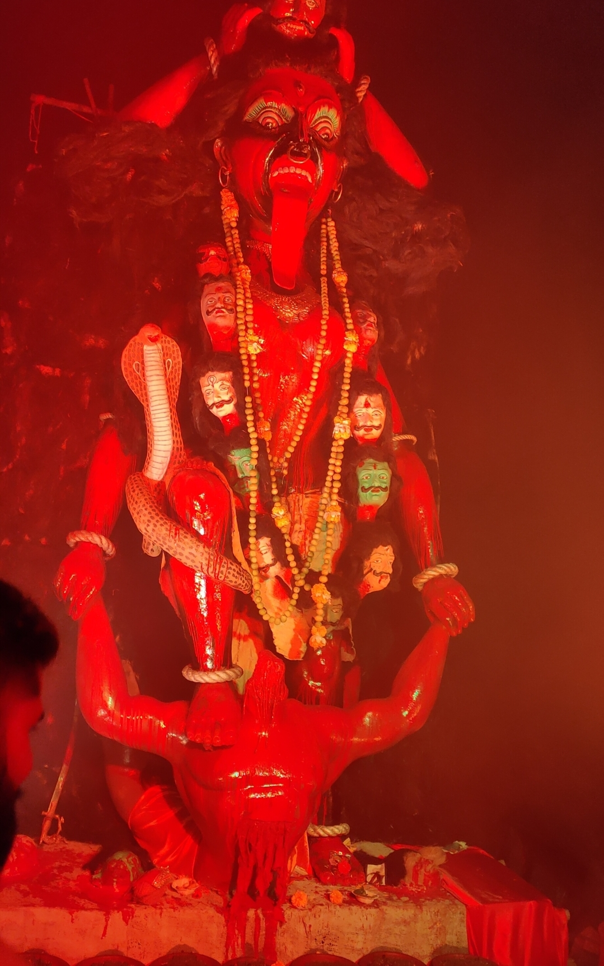

    **Figure 1: Idol of Goddess Kali placed near Kalibadi intersection in Bhopal for 11 days.**

    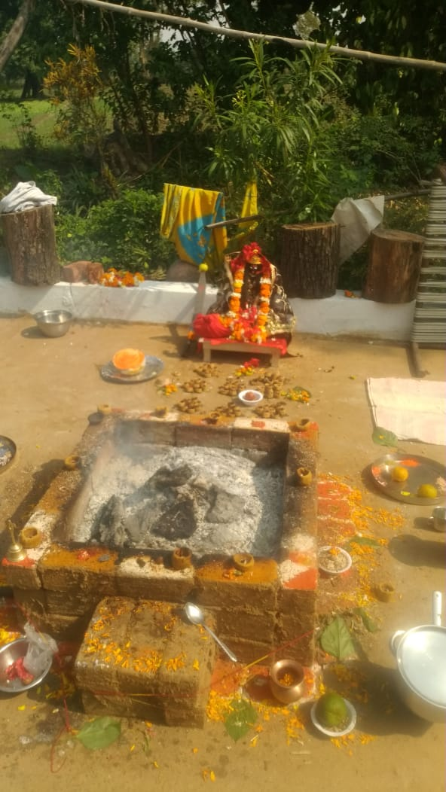

    **Figure 2: Hawan performed in front of Goddess Kali before sacrifice in Kotra, Bhopal.**

    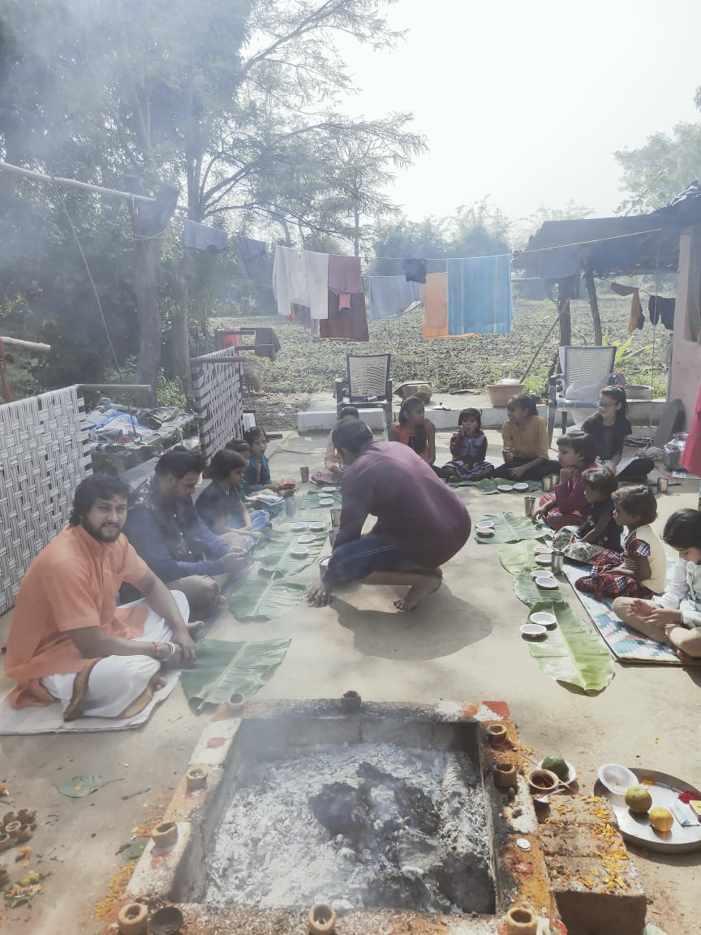

    **Figure 3: Bhandara followed by Hawan and Sacrifice at Ayodhya by pass, Bhopal.**

    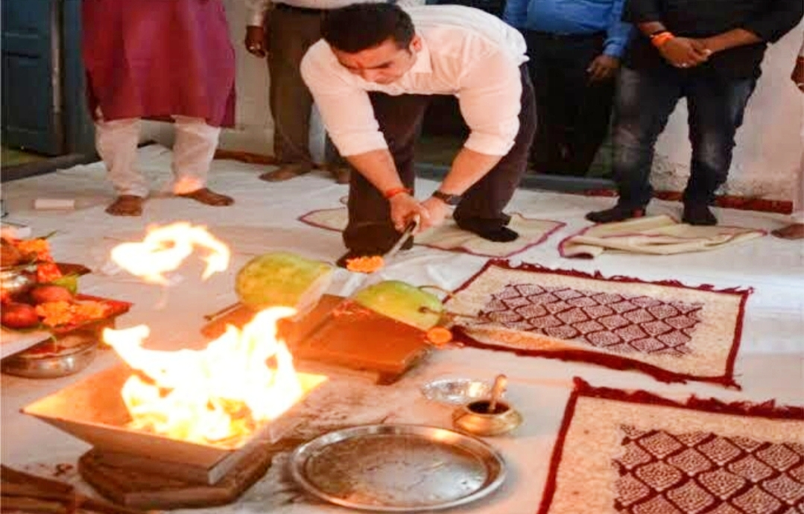

    **Figure 4: Sacrifice of white pumpkin by cutting it with a sword in one stroke in Navratri Pandal, Ibrahimpura, Bhopal.**